Identify capacity throughout the day

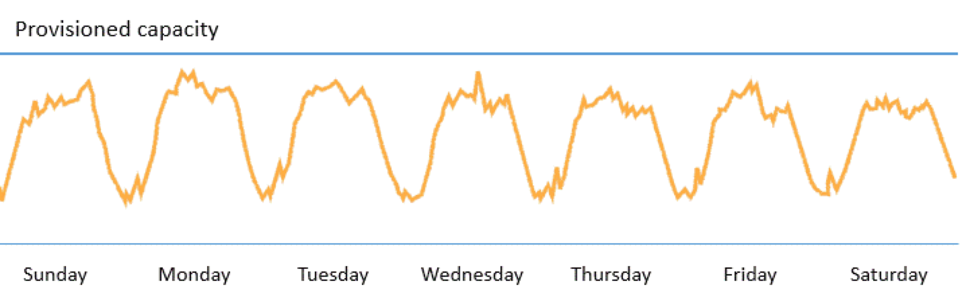

<https://www.uber.com/blog/data-visualization-intelligence/>

<http://eng.uber.com/wp-content/uploads/2016/05/allenkey.gif>

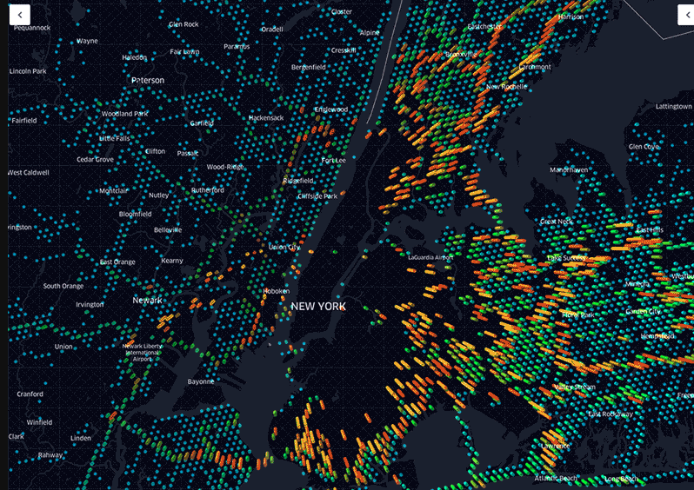

Calculate data per day

* 10 million bookings per day
* Each booking average of 2MB of data
* 10 Million \* 2 MB = 20 Million MB = 20,000,000 Mb = 20,000 GB = 20 TB of data